**Ядовитые скорпионы**

[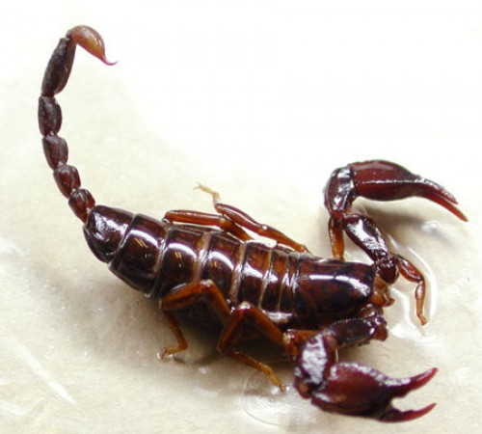](http://images.yandex.ru/yandsearch?source=wiz&text=%D1%8F%D0%B4%D0%BE%D0%B2%D0%B8%D1%82%D1%8B%D0%B5%20%D1%81%D0%BA%D0%BE%D1%80%D0%BF%D0%B8%D0%BE%D0%BD%D1%8B&noreask=1&pos=1&rpt=simage&lr=9&uinfo=ww-1355-wh-716-fw-1130-fh-510-pd-1.0499999523162841&img_url=http://img0.liveinternet.ru/images/attach/b/3/41/896/41896957_skorpion.jpg)

[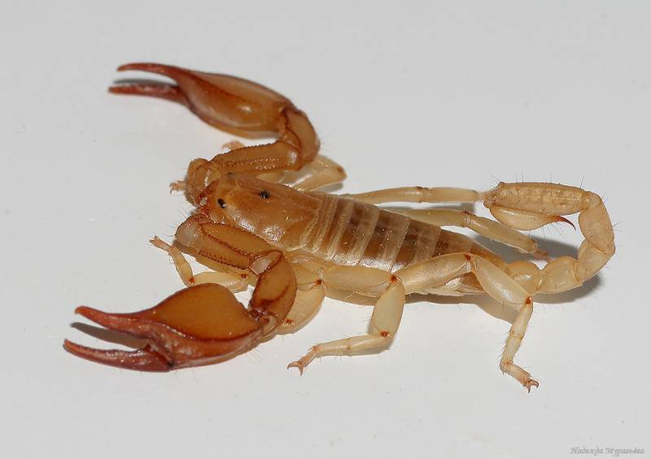](http://images.yandex.ru/yandsearch?source=wiz&uinfo=ww-1355-wh-716-fw-1130-fh-510-pd-1.0499999523162841&p=6&text=%D1%8F%D0%B4%D0%BE%D0%B2%D0%B8%D1%82%D1%8B%D0%B5%20%D1%81%D0%BA%D0%BE%D1%80%D0%BF%D0%B8%D0%BE%D0%BD%D1%8B&noreask=1&pos=209&rpt=simage&lr=9&img_url=http://gigamir.net/upload/cache/120x90/img/content/originnal_764e8b11ccfb6ad5867cfa6bac6f83db.jpg)

[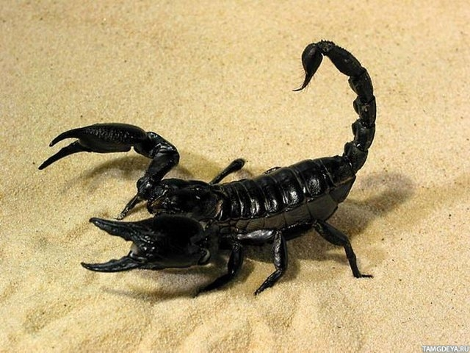](http://images.yandex.ru/yandsearch?source=wiz&text=%D1%8F%D0%B4%D0%BE%D0%B2%D0%B8%D1%82%D1%8B%D0%B5%20%D1%81%D0%BA%D0%BE%D1%80%D0%BF%D0%B8%D0%BE%D0%BD%D1%8B&noreask=1&pos=18&rpt=simage&lr=9&uinfo=ww-1355-wh-716-fw-1130-fh-510-pd-1.0499999523162841&img_url=http://img-fotki.yandex.ru/get/5413/130422193.7b/0_6e24f_c8f2c561_orig)

[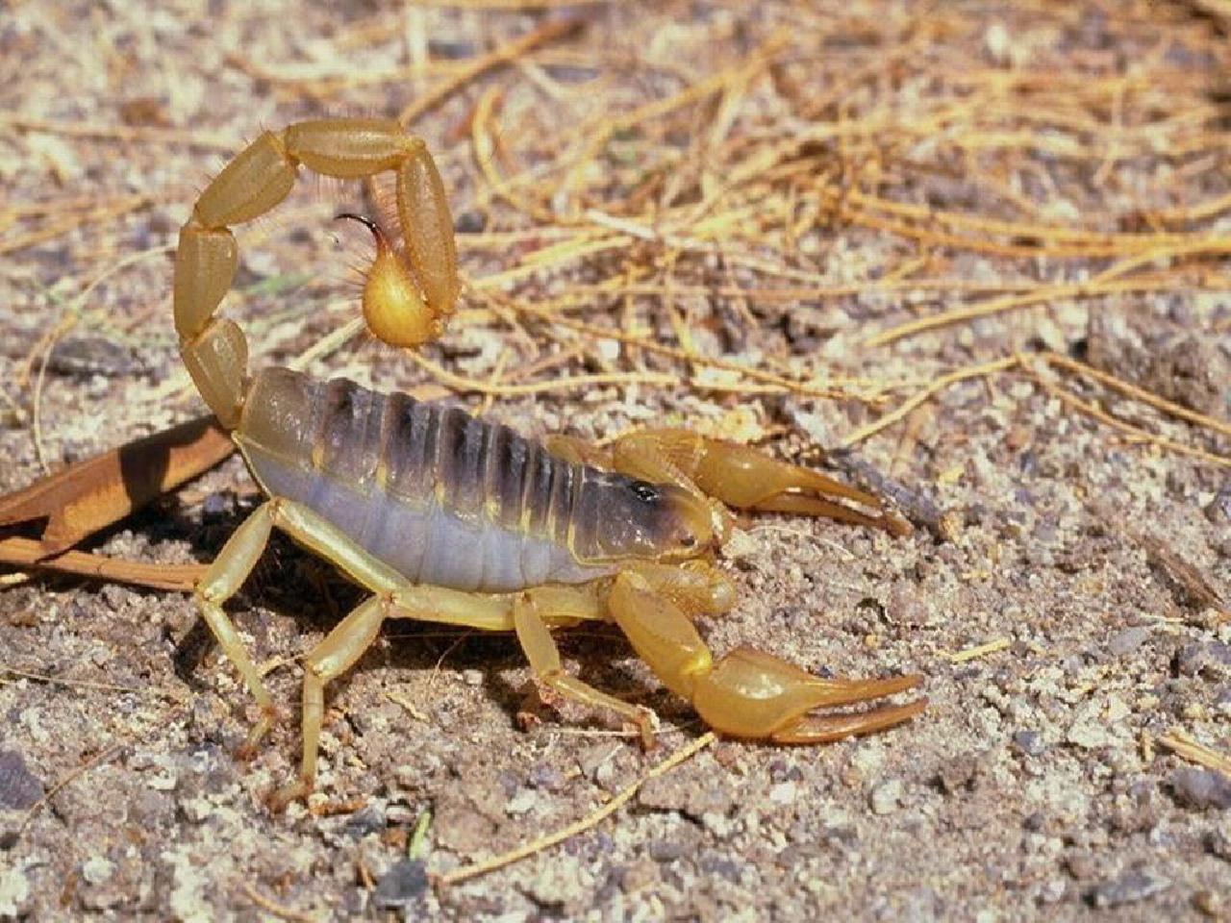](http://images.yandex.ru/yandsearch?source=wiz&text=%D1%8F%D0%B4%D0%BE%D0%B2%D0%B8%D1%82%D1%8B%D0%B5%20%D1%81%D0%BA%D0%BE%D1%80%D0%BF%D0%B8%D0%BE%D0%BD%D1%8B&noreask=1&pos=7&rpt=simage&lr=9&uinfo=ww-1355-wh-716-fw-1130-fh-510-pd-1.0499999523162841&img_url=http://shkolazhizni.ru/img/content/i57/57653.jpg)

[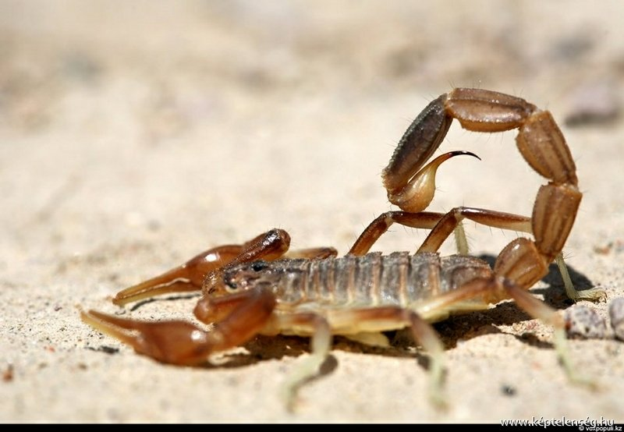](http://images.yandex.ru/yandsearch?source=wiz&uinfo=ww-1355-wh-716-fw-1130-fh-510-pd-1.0499999523162841&p=6&text=%D1%8F%D0%B4%D0%BE%D0%B2%D0%B8%D1%82%D1%8B%D0%B5%20%D1%81%D0%BA%D0%BE%D1%80%D0%BF%D0%B8%D0%BE%D0%BD%D1%8B&noreask=1&pos=185&rpt=simage&lr=9&img_url=http://mainfun.ru/image/17/34/32.jpg)

[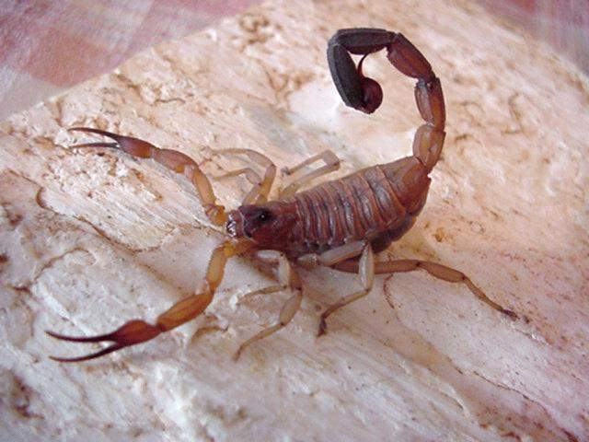](http://images.yandex.ru/yandsearch?source=wiz&uinfo=ww-1355-wh-716-fw-1130-fh-510-pd-1.0499999523162841&p=2&text=%D1%8F%D0%B4%D0%BE%D0%B2%D0%B8%D1%82%D1%8B%D0%B5%20%D1%81%D0%BA%D0%BE%D1%80%D0%BF%D0%B8%D0%BE%D0%BD%D1%8B&noreask=1&pos=70&rpt=simage&lr=9&img_url=http://e.elcomercio.pe/66/ima/0/0/1/2/7/127701.jpg)

[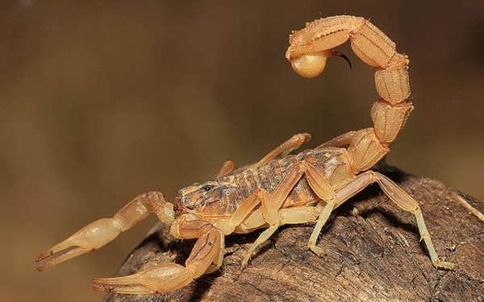](http://images.yandex.ru/yandsearch?source=wiz&uinfo=ww-1355-wh-716-fw-1130-fh-510-pd-1.0499999523162841&p=2&text=%D1%8F%D0%B4%D0%BE%D0%B2%D0%B8%D1%82%D1%8B%D0%B5%20%D1%81%D0%BA%D0%BE%D1%80%D0%BF%D0%B8%D0%BE%D0%BD%D1%8B&noreask=1&pos=76&rpt=simage&lr=9&img_url=http://www.infoniac.ru/upload/medialibrary/627/627fb1fc200940e5521faf889cf1c1b5.jpg)

[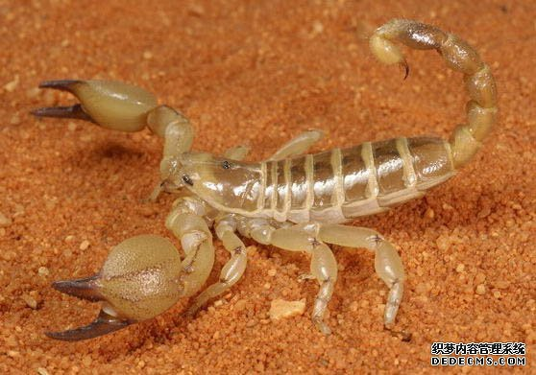](http://images.yandex.ru/yandsearch?source=wiz&uinfo=ww-1355-wh-716-fw-1130-fh-510-pd-1.0499999523162841&p=2&text=%D1%8F%D0%B4%D0%BE%D0%B2%D0%B8%D1%82%D1%8B%D0%B5%20%D1%81%D0%BA%D0%BE%D1%80%D0%BF%D0%B8%D0%BE%D0%BD%D1%8B&noreask=1&pos=71&rpt=simage&lr=9&img_url=http://www.stihi.ru/photos/dana3.jpg)

[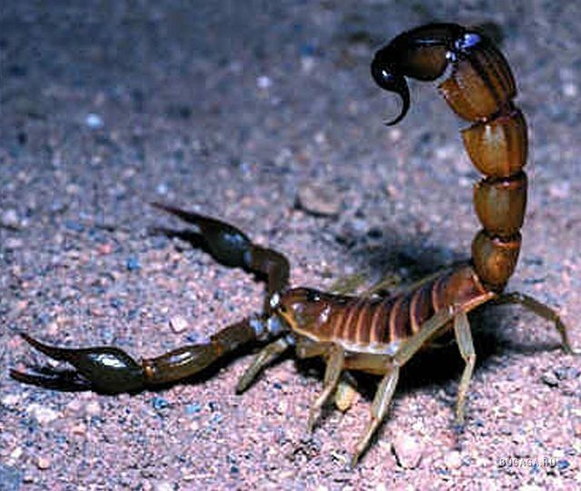](http://images.yandex.ru/yandsearch?source=wiz&text=%D1%8F%D0%B4%D0%BE%D0%B2%D0%B8%D1%82%D1%8B%D0%B5%20%D1%81%D0%BA%D0%BE%D1%80%D0%BF%D0%B8%D0%BE%D0%BD%D1%8B&noreask=1&pos=15&rpt=simage&lr=9&uinfo=ww-1355-wh-716-fw-1130-fh-510-pd-1.0499999523162841&img_url=http://www.calacademy.org/exhibits/venoms/images/00_final/death_stalker_scorpion2.jpg)

[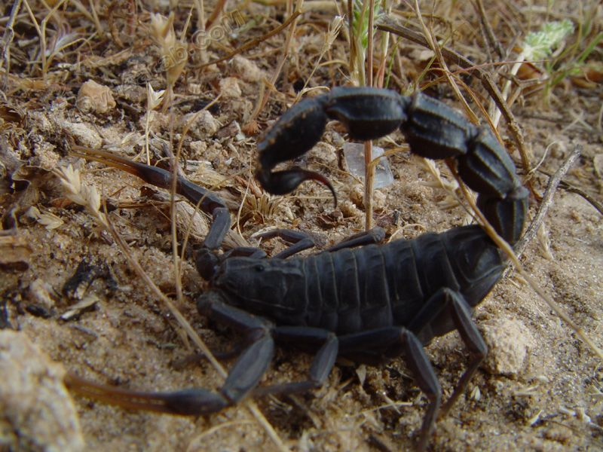](http://images.yandex.ru/yandsearch?source=wiz&uinfo=ww-1355-wh-716-fw-1130-fh-510-pd-1.0499999523162841&p=1&text=%D1%8F%D0%B4%D0%BE%D0%B2%D0%B8%D1%82%D1%8B%D0%B5%20%D1%81%D0%BA%D0%BE%D1%80%D0%BF%D0%B8%D0%BE%D0%BD%D1%8B&noreask=1&pos=31&rpt=simage&lr=9&img_url=http://unnatural.ru/images/nasekomoe/5.jpg)

[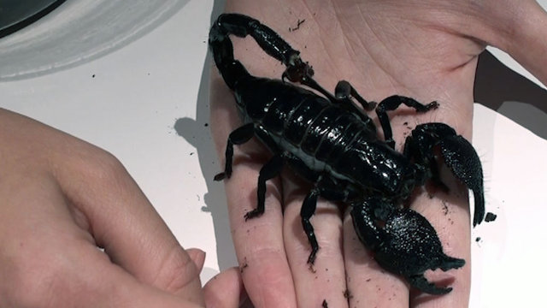](http://images.yandex.ru/yandsearch?source=wiz&uinfo=ww-1355-wh-716-fw-1130-fh-510-pd-1.0499999523162841&p=2&text=%D1%8F%D0%B4%D0%BE%D0%B2%D0%B8%D1%82%D1%8B%D0%B5%20%D1%81%D0%BA%D0%BE%D1%80%D0%BF%D0%B8%D0%BE%D0%BD%D1%8B&noreask=1&pos=80&rpt=simage&lr=9&img_url=http://img.beta.rian.ru/images/70893/58/708935858.jpg)

[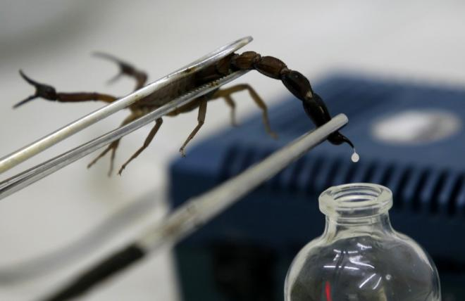](http://images.yandex.ru/yandsearch?source=wiz&text=%D1%8F%D0%B4%D0%BE%D0%B2%D0%B8%D1%82%D1%8B%D0%B5%20%D1%81%D0%BA%D0%BE%D1%80%D0%BF%D0%B8%D0%BE%D0%BD%D1%8B&noreask=1&pos=26&rpt=simage&lr=9&uinfo=ww-1355-wh-716-fw-1130-fh-510-pd-1.0499999523162841&img_url=http://bigpicture.ru/wp-content/uploads/2011/08/animal31.jpg)

[](http://images.yandex.ru/yandsearch?source=wiz&uinfo=ww-1355-wh-716-fw-1130-fh-510-pd-1.0499999523162841&p=6&text=%D1%8F%D0%B4%D0%BE%D0%B2%D0%B8%D1%82%D1%8B%D0%B5%20%D1%81%D0%BA%D0%BE%D1%80%D0%BF%D0%B8%D0%BE%D0%BD%D1%8B&noreask=1&pos=182&rpt=simage&lr=9&img_url=http://ppt4web.ru/images/5418/78340/310/img16.jpg)