**Кукушка обыкновенная**

[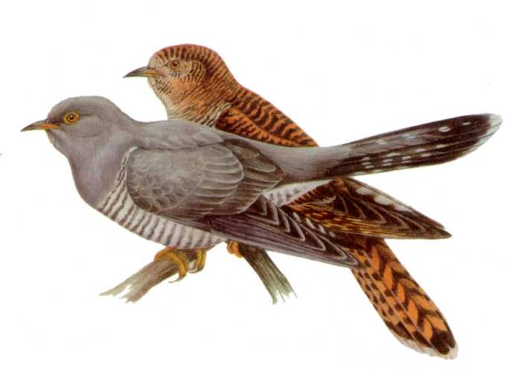](http://images.yandex.ru/yandsearch?source=wiz&fp=0&text=%D1%84%D0%BE%D1%82%D0%BE%20%D0%BA%D1%83%D0%BA%D1%83%D1%88%D0%BA%D0%B8%20%D0%BE%D0%B1%D1%8B%D0%BA%D0%BD%D0%BE%D0%B2%D0%B5%D0%BD%D0%BD%D0%BE%D0%B9&noreask=1&pos=0&lr=9&rpt=simage&uinfo=ww-1355-wh-716-fw-1130-fh-510-pd-1.0499999523162841&img_url=http://900igr.net/Detskie_prezentatsii/nasekomye_i_ptitsy/Ptitsy_lesa_2.files/slide0024_image023.jpg)

[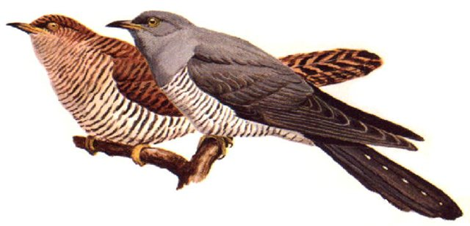](http://images.yandex.ru/yandsearch?source=wiz&fp=4&uinfo=ww-1355-wh-716-fw-1130-fh-510-pd-1.0499999523162841&p=4&text=%D1%84%D0%BE%D1%82%D0%BE%20%D0%BA%D1%83%D0%BA%D1%83%D1%88%D0%BA%D0%B8%20%D0%BE%D0%B1%D1%8B%D0%BA%D0%BD%D0%BE%D0%B2%D0%B5%D0%BD%D0%BD%D0%BE%D0%B9&noreask=1&pos=123&rpt=simage&lr=9&img_url=http://www.hayvansevgisi.net/yuklenenresimler/guguk-kusu01082009.jpg)

[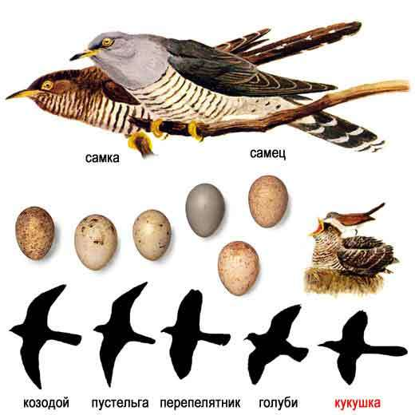](http://images.yandex.ru/yandsearch?source=wiz&fp=4&uinfo=ww-1355-wh-716-fw-1130-fh-510-pd-1.0499999523162841&p=4&text=%D1%84%D0%BE%D1%82%D0%BE%20%D0%BA%D1%83%D0%BA%D1%83%D1%88%D0%BA%D0%B8%20%D0%BE%D0%B1%D1%8B%D0%BA%D0%BD%D0%BE%D0%B2%D0%B5%D0%BD%D0%BD%D0%BE%D0%B9&noreask=1&pos=149&rpt=simage&lr=9&img_url=http://www.ecosystema.ru/08nature/birds/086.jpg)

[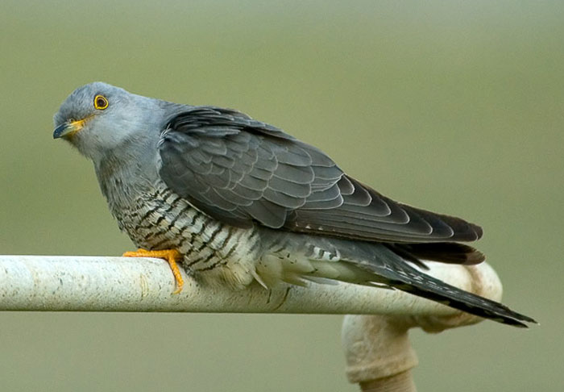](http://images.yandex.ru/yandsearch?source=wiz&fp=0&text=%D1%84%D0%BE%D1%82%D0%BE%20%D0%BA%D1%83%D0%BA%D1%83%D1%88%D0%BA%D0%B8%20%D0%BE%D0%B1%D1%8B%D0%BA%D0%BD%D0%BE%D0%B2%D0%B5%D0%BD%D0%BD%D0%BE%D0%B9&noreask=1&pos=6&lr=9&rpt=simage&uinfo=ww-1355-wh-716-fw-1130-fh-510-pd-1.0499999523162841&img_url=http://www.factroom.ru/wp-content/uploads/2012/04/101.jpg)

[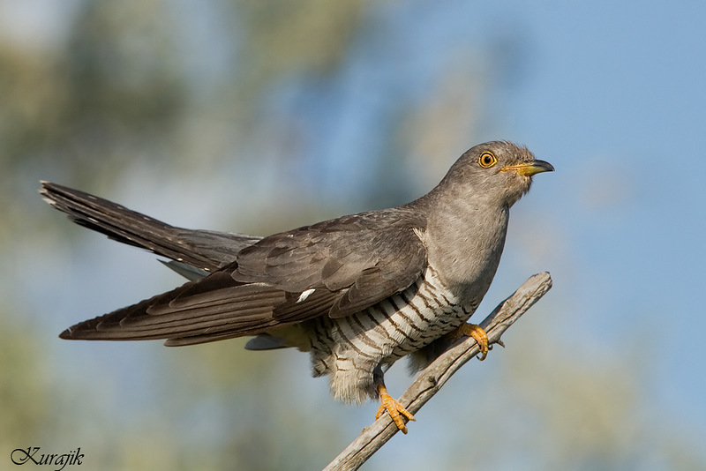](http://images.yandex.ru/yandsearch?source=wiz&fp=1&uinfo=ww-1355-wh-716-fw-1130-fh-510-pd-1.0499999523162841&p=1&text=%D1%84%D0%BE%D1%82%D0%BE%20%D0%BA%D1%83%D0%BA%D1%83%D1%88%D0%BA%D0%B8%20%D0%BE%D0%B1%D1%8B%D0%BA%D0%BD%D0%BE%D0%B2%D0%B5%D0%BD%D0%BD%D0%BE%D0%B9&noreask=1&pos=48&rpt=simage&lr=9&img_url=http://img-fotki.yandex.ru/get/4713/36014923.2c/0_6d0b5_59a9da17_S)

[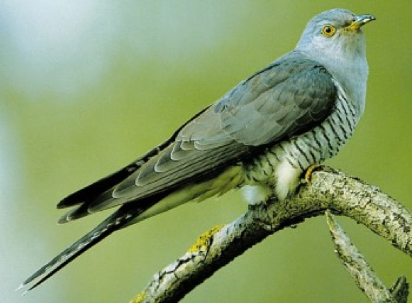](http://images.yandex.ru/yandsearch?source=wiz&fp=0&text=%D1%84%D0%BE%D1%82%D0%BE%20%D0%BA%D1%83%D0%BA%D1%83%D1%88%D0%BA%D0%B8%20%D0%BE%D0%B1%D1%8B%D0%BA%D0%BD%D0%BE%D0%B2%D0%B5%D0%BD%D0%BD%D0%BE%D0%B9&noreask=1&pos=8&lr=9&rpt=simage&uinfo=ww-1355-wh-716-fw-1130-fh-510-pd-1.0499999523162841&img_url=http://birds-altay.ru/wp-content/uploads/2009/11/5-350x257.jpg)

[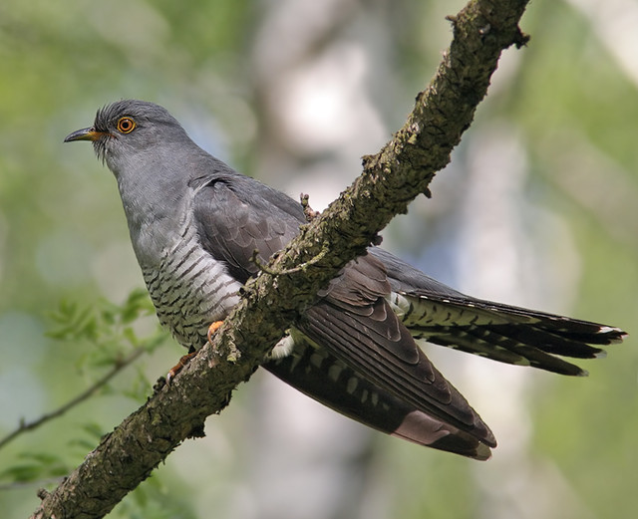](http://images.yandex.ru/yandsearch?source=wiz&fp=0&text=%D1%84%D0%BE%D1%82%D0%BE%20%D0%BA%D1%83%D0%BA%D1%83%D1%88%D0%BA%D0%B8%20%D0%BE%D0%B1%D1%8B%D0%BA%D0%BD%D0%BE%D0%B2%D0%B5%D0%BD%D0%BD%D0%BE%D0%B9&noreask=1&pos=13&lr=9&rpt=simage&uinfo=ww-1355-wh-716-fw-1130-fh-510-pd-1.0499999523162841&img_url=http://club.foto.ru/gallery/images/thumb/2008/05/06/1096856.jpg)

[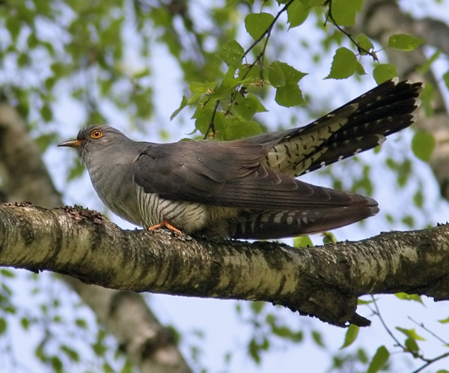](http://images.yandex.ru/yandsearch?source=wiz&fp=0&text=%D1%84%D0%BE%D1%82%D0%BE%20%D0%BA%D1%83%D0%BA%D1%83%D1%88%D0%BA%D0%B8%20%D0%BE%D0%B1%D1%8B%D0%BA%D0%BD%D0%BE%D0%B2%D0%B5%D0%BD%D0%BD%D0%BE%D0%B9&noreask=1&pos=11&lr=9&rpt=simage&uinfo=ww-1355-wh-716-fw-1130-fh-510-pd-1.0499999523162841&img_url=http://shkolazhizni.ru/img/content/i72/72493_or.jpg)

[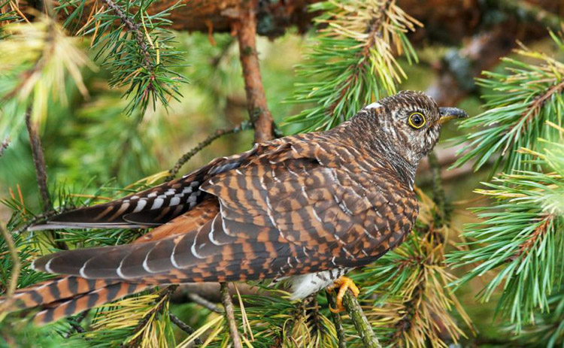](http://images.yandex.ru/yandsearch?source=wiz&fp=0&text=%D1%84%D0%BE%D1%82%D0%BE%20%D0%BA%D1%83%D0%BA%D1%83%D1%88%D0%BA%D0%B8%20%D0%BE%D0%B1%D1%8B%D0%BA%D0%BD%D0%BE%D0%B2%D0%B5%D0%BD%D0%BD%D0%BE%D0%B9&noreask=1&pos=10&lr=9&rpt=simage&uinfo=ww-1355-wh-716-fw-1130-fh-510-pd-1.0499999523162841&img_url=http://mediasubs.ru/group/uploads/mi/mir-iskusstva-tvorchestva-i-krasotyi/image2/DI5LThkOD.jpg)

[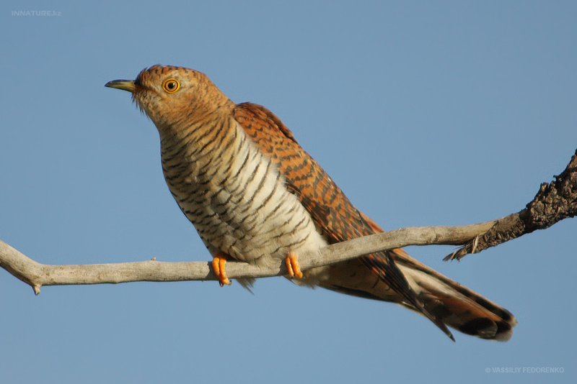](http://images.yandex.ru/yandsearch?source=wiz&fp=1&uinfo=ww-1355-wh-716-fw-1130-fh-510-pd-1.0499999523162841&p=1&text=%D1%84%D0%BE%D1%82%D0%BE%20%D0%BA%D1%83%D0%BA%D1%83%D1%88%D0%BA%D0%B8%20%D0%BE%D0%B1%D1%8B%D0%BA%D0%BD%D0%BE%D0%B2%D0%B5%D0%BD%D0%BD%D0%BE%D0%B9&noreask=1&pos=53&rpt=simage&lr=9&img_url=http://photo2.ask.fm/303/979/932/910003023-1qhnqd4-djk7om3ihs251bk/preview/hvsmczgf.jpg)

[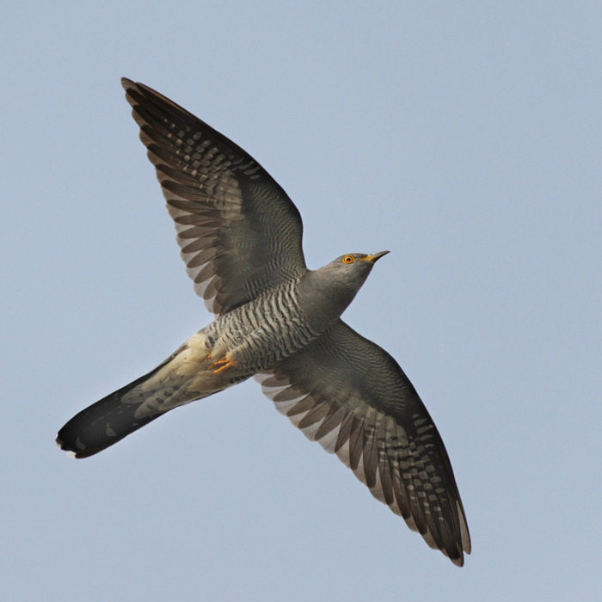](http://images.yandex.ru/yandsearch?source=wiz&fp=5&uinfo=ww-1355-wh-716-fw-1130-fh-510-pd-1.0499999523162841&p=5&text=%D1%84%D0%BE%D1%82%D0%BE%20%D0%BA%D1%83%D0%BA%D1%83%D1%88%D0%BA%D0%B8%20%D0%BE%D0%B1%D1%8B%D0%BA%D0%BD%D0%BE%D0%B2%D0%B5%D0%BD%D0%BD%D0%BE%D0%B9&noreask=1&pos=176&rpt=simage&lr=9&img_url=http://img0.liveinternet.ru/images/attach/c/6/91/812/91812772_kukushka9.jpg)

[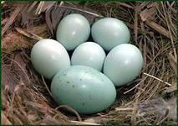](http://images.yandex.ru/yandsearch?source=wiz&fp=2&img_url=http://www.balatsky.ru/Cuc_Russii/Cuckooo.files/image005.jpg&uinfo=ww-1355-wh-716-fw-1130-fh-510-pd-1.0499999523162841&p=2&text=%D1%84%D0%BE%D1%82%D0%BE%20%D0%BA%D1%83%D0%BA%D1%83%D1%88%D0%BA%D0%B8%20%D0%BE%D0%B1%D1%8B%D0%BA%D0%BD%D0%BE%D0%B2%D0%B5%D0%BD%D0%BD%D0%BE%D0%B9&noreask=1&pos=87&rpt=simage&lr=9)

[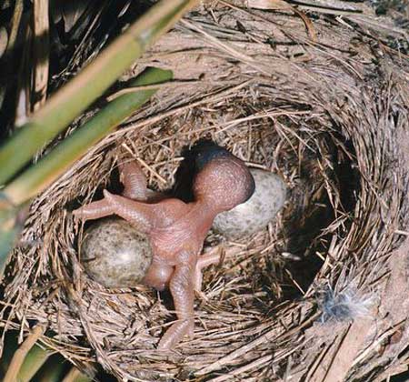](http://images.yandex.ru/yandsearch?source=wiz&fp=8&uinfo=ww-1355-wh-716-fw-1130-fh-510-pd-1.0499999523162841&p=8&text=%D1%84%D0%BE%D1%82%D0%BE%20%D0%BA%D1%83%D0%BA%D1%83%D1%88%D0%BA%D0%B8%20%D0%BE%D0%B1%D1%8B%D0%BA%D0%BD%D0%BE%D0%B2%D0%B5%D0%BD%D0%BD%D0%BE%D0%B9&noreask=1&pos=256&rpt=simage&lr=9&img_url=http://www.tepid.ru/images/cuckoo-4.jpg)

[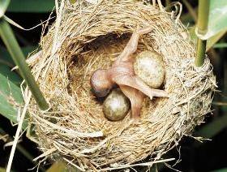](http://images.yandex.ru/yandsearch?source=wiz&fp=2&uinfo=ww-1355-wh-716-fw-1130-fh-510-pd-1.0499999523162841&p=2&text=%D1%84%D0%BE%D1%82%D0%BE%20%D0%BA%D1%83%D0%BA%D1%83%D1%88%D0%BA%D0%B8%20%D0%BE%D0%B1%D1%8B%D0%BA%D0%BD%D0%BE%D0%B2%D0%B5%D0%BD%D0%BD%D0%BE%D0%B9&noreask=1&pos=76&rpt=simage&lr=9&img_url=http://www.strausof.net/wp-content/uploads/2011/01/kukushki_280_200_4.jpg)

[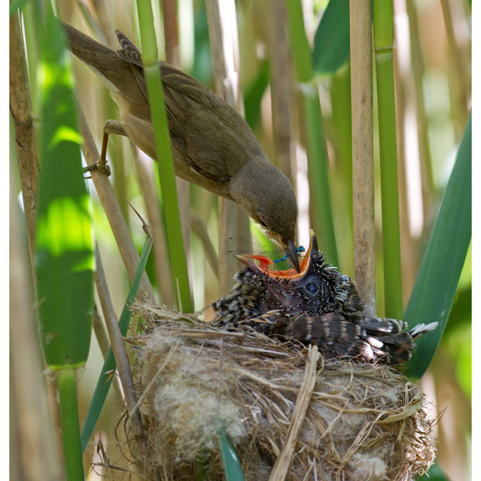](http://images.yandex.ru/yandsearch?source=wiz&fp=7&uinfo=ww-1355-wh-716-fw-1130-fh-510-pd-1.0499999523162841&p=7&text=%D1%84%D0%BE%D1%82%D0%BE%20%D0%BA%D1%83%D0%BA%D1%83%D1%88%D0%BA%D0%B8%20%D0%BE%D0%B1%D1%8B%D0%BA%D0%BD%D0%BE%D0%B2%D0%B5%D0%BD%D0%BD%D0%BE%D0%B9&noreask=1&pos=232&rpt=simage&lr=9&img_url=http://www.asriran.com/files/fa/news/1390/4/4/178849_273.jpg)

[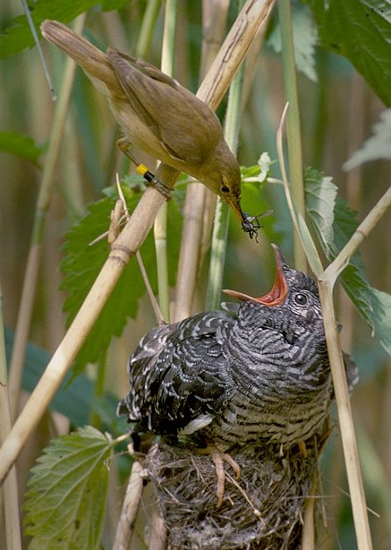](http://images.yandex.ru/yandsearch?source=wiz&fp=5&uinfo=ww-1355-wh-716-fw-1130-fh-510-pd-1.0499999523162841&p=5&text=%D1%84%D0%BE%D1%82%D0%BE%20%D0%BA%D1%83%D0%BA%D1%83%D1%88%D0%BA%D0%B8%20%D0%BE%D0%B1%D1%8B%D0%BA%D0%BD%D0%BE%D0%B2%D0%B5%D0%BD%D0%BD%D0%BE%D0%B9&noreask=1&pos=153&rpt=simage&lr=9&img_url=http://maxpark.com/static/u/article_image/13/04/23/tmpDx3RHu.jpeg)

[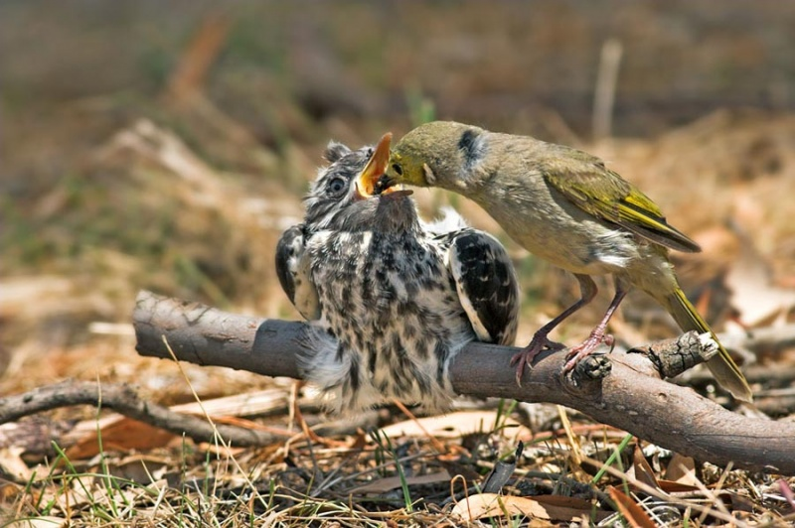](http://images.yandex.ru/yandsearch?source=wiz&fp=0&text=%D1%84%D0%BE%D1%82%D0%BE%20%D0%BA%D1%83%D0%BA%D1%83%D1%88%D0%BA%D0%B8%20%D0%BE%D0%B1%D1%8B%D0%BA%D0%BD%D0%BE%D0%B2%D0%B5%D0%BD%D0%BD%D0%BE%D0%B9&noreask=1&pos=25&lr=9&rpt=simage&uinfo=ww-1355-wh-716-fw-1130-fh-510-pd-1.0499999523162841&img_url=http://img0.liveinternet.ru/images/attach/c/4/81/29/81029106_cuculcuculuscanorus2.jpg)

[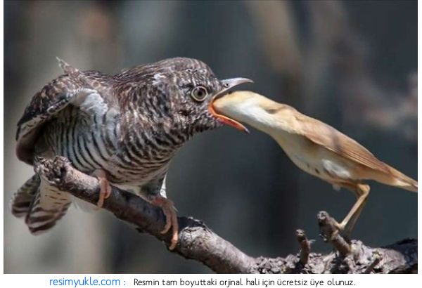](http://images.yandex.ru/yandsearch?source=wiz&fp=1&uinfo=ww-1355-wh-716-fw-1130-fh-510-pd-1.0499999523162841&p=1&text=%D1%84%D0%BE%D1%82%D0%BE%20%D0%BA%D1%83%D0%BA%D1%83%D1%88%D0%BA%D0%B8%20%D0%BE%D0%B1%D1%8B%D0%BA%D0%BD%D0%BE%D0%B2%D0%B5%D0%BD%D0%BD%D0%BE%D0%B9&noreask=1&pos=52&rpt=simage&lr=9&img_url=http://cdn.trinixy.ru/pics4/20110811/podb/3/best_animal_pics_48.jpg)

[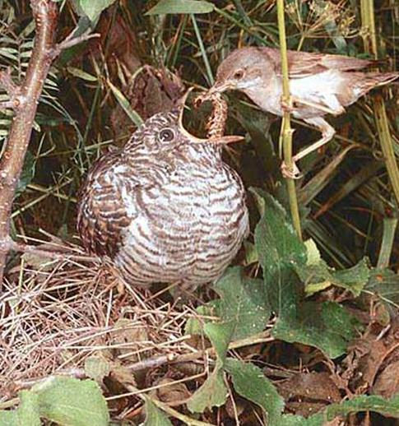](http://images.yandex.ru/yandsearch?source=wiz&fp=0&text=%D1%84%D0%BE%D1%82%D0%BE%20%D0%BA%D1%83%D0%BA%D1%83%D1%88%D0%BA%D0%B8%20%D0%BE%D0%B1%D1%8B%D0%BA%D0%BD%D0%BE%D0%B2%D0%B5%D0%BD%D0%BD%D0%BE%D0%B9&noreask=1&pos=28&lr=9&rpt=simage&uinfo=ww-1355-wh-716-fw-1130-fh-510-pd-1.0499999523162841&img_url=http://img0.liveinternet.ru/images/attach/c/5/87/122/87122508_KUK01.JPG)

[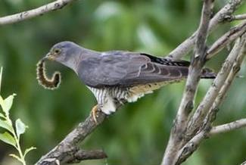](http://images.yandex.ru/yandsearch?source=wiz&fp=1&uinfo=ww-1355-wh-716-fw-1130-fh-510-pd-1.0499999523162841&p=1&text=%D1%84%D0%BE%D1%82%D0%BE%20%D0%BA%D1%83%D0%BA%D1%83%D1%88%D0%BA%D0%B8%20%D0%BE%D0%B1%D1%8B%D0%BA%D0%BD%D0%BE%D0%B2%D0%B5%D0%BD%D0%BD%D0%BE%D0%B9&noreask=1&pos=41&rpt=simage&lr=9&img_url=http://img01.chitalnya.ru/upload/637/8985162852331996.jpg)